GOT NOTES, GO RAST.

LGCWEEKY: Constructive ambiguity

Colour key - Venn Jordan Pedro
The Jordan
https://meet.jit.si/jordan9000#config.disableAP=true&config.disableAEC=true&config.disableAGC=true

The Pedro
https://meet.jit.si/pedro9000#config.disableAP=true&config.disableAEC=true&config.disableAGC=true

Need to remember - post finished show in google Linux group.

PICK YOUR FUKIN’ STORIES!

Remember to ask shatrealm to come up with Show Title.

Intro-
grep ^http links.txt | tr "\n" " " | sed 's/\&/\\\&/g' | xargs firefox lynx curl

Vote for Showtitles: vote.linuxgamecast.com

INTRO : ???????????????????????????? <- !!!!!!!!!!!!!!!!

Rundown:

OG DOOM gets a Battle Royale MOD
- Because of course it did
And taking on Steam with a blockchain
- Stick around, we’ll attempt to explain how.

Valve Fixes VR For Linux
- Shame no games actually use it
Sunless skies is out in january
- They wrote you a book to tide you over though

VALVe breaks down the numbers
- Of controllers...
And PlayOnLinux counts to 5
- And it learned some javascript along the way

What we’re up to :
V - Playing /w Fire.
J -
P -

Colour key: Venn Jordan Pedro
Party Patreons: Post story suggestions HAR!

Links
Steam: News

Controllas
https://steamcommunity.com/games/593110/announcements/detail/1712946892833213377
- 195k Steam Users using SNES controllers.
- The 360 controller being on top shouldn't surprise anyone
  - Yeah, considering xinput devices = XBOX.
- The article also echoes my sentiments about the ds4, which on Linux is a lot easier to get set up
- And now I’m even more tempted to get one of those Switch pro controllers but I’d probably end up not using it all that much.

SPCR for Steam
https://github.com/tryton-vanmeer/SPCR-for-Steam#spcr-for-steam
- Handy because my brain-organ flat-out refuses to remember the URL.
- Needs more Chrome

VR Crash
https://steamcommunity.com/games/250820/announcements/detail/1696059661063908661
- Ayyy steam vr gets some linux fixes
- Now how about some games to take advantage of said fixes

Steamy compitition
https://www.pcgamer.com/robot-cache-takes-aim-at-steam-with-digital-store-that-lets-you-resell-your-games/
- Alright, securing digital sales with blockchain is kinda neat.
- Being able to resell games, double so.
  - That is ripe for abuse
- Especially with developers creating artificial scarcity to drive up price of their stuff.
Steam: Game Updates

Sunless Skies exits Early Access
https://steamcommunity.com/games/596970/announcements/detail/1690429528451486058
- Sequel/spiritual successor comes out at the end of January
- They also made a tabletop RPG for it, which I perused
  - It's pretty clearly a small scope game, inspired by apocalypse world

Rocket Cars v1.53
https://steamcommunity.com/games/252950/announcements/detail/1708443926974701379
- Bunch of Hot Wheels stuff to decorate your business with.
- Hot Wheels Rivals’ is now available as a playable Arena in Casual Playlists, Tournaments, Private Matches and Offline Matches
- And of course, another £4 worth of DLC cars.

Seeker and Slayer
https://steamcommunity.com/games/560130/announcements/detail/1694933128101258458
- New game+ mods to spice up replayability
- Megabosses have been added to put your munchkining skills to the test
- Why one would want a kill can in an isometric RPG is beyond me, but you have one now and you can configure it
- As usual, a host of gameplay and AI fixes are also included

Chimply amazing
https://steamcommunity.com/games/386940/announcements/detail/1684800028939600138
- Stupid monkey update mumble grumble
- 3 new levels including the nuclear plant and the mainframe
- A few more.fucky block types you can use to attempt to screw over your friends but actually fuck yourself
- You can also customize the bejeezus out the match, adjusting scoring, block appearance rates and more

Blade Symphony
https://store.steampowered.com/app/225600/Blade_Symphony/
- Latest update adds Linux support.
- Porting to the latest Source engine allowed this.
- The update also includes a gentler learning curve: being inspired by games such as Jedi Knight's lightsaber duels and Soul Calibur.
- That said, if you are trying to make this friendly to newcomers ya might want to unfuck your controller settings.
  - 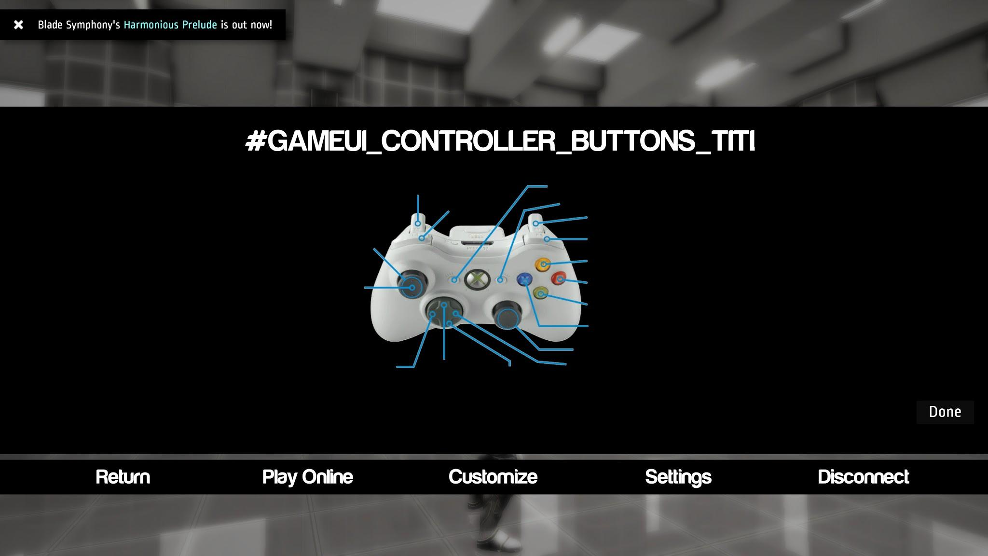
- Using the Steam Contolla (on a game built /w the source Engine) no button prompts are shown and “grab” is not even mapped.
Steam: New Games

BATTLETECH
https://steamcommunity.com/games/637090/announcements/detail/1699437360785419573
- Available in Beta on Steam only. When it goes live, it will release on all supported distribution platforms.
- Multiplayer has some… issues.
- Thanks to Jeremy from PCper for letting me know.
- Hoo boy, this is a pleasant surprise. Good job Hairbrained
- This has the potential to be another time sink for me. Turned based giant robot shenanigans

Total War: Kingdoms or something
https://store.steampowered.com/app/779340/Total_War_THREE_KINGDOMS/
- THREE KINGDOMS is coming to Linux shortly after the Windows release on March 7th, 2019 according to a Feral human.
  - You know, considering feral;s turnaround time usually, that’s not too bad
- It’s got to be a FSM damned awesome time to be a TOTES WAR fan and a Linux user.

Multiplayer Bomberman
https://store.steampowered.com/app/931260/Multibombers/
- It’s EXTREMELY basic but makes /w the working.
- The first person perspective has me curious
- Though, I can imagine the claustrophobia it will cause.

Jack V
https://store.steampowered.com/app/774461/The_Jackbox_Party_Pack_5/
- Hope they maintain their unofficial Linux support for part 5.
- Oh look, Linux support added to the preorder page.

Niffelheim
https://store.steampowered.com/app/351100/Niffelheim/
- Looks nice.
- 
  - Bit of a salt and sanctuary vibe
  - Online multiplayer is a nice touch
- Don’t know if I’m a fan of the animation rigging.
- Looks a bit ragdoll.
- I liked Salt & Sanctuary a lot but this one, going from the trailer, doesn’t seem to be selling me on it.
- It may also be that games like this are dime-a-dozen on Steam nowadays.
- Don’t get me wrong, I’m glad we’re past the hipster pixel bullshit, but I’d like something with a bit more depth… dimensionally speaking.

We Don’t Like 4.0: Kingmaker
https://store.steampowered.com/app/640820/Pathfinder_Kingmaker/
- Like Baldur’s Gate? Hate AD&D? Here’s one for ya!
- Apparently this one is pretty good though. A lot of my PF complaints come from shitty incentivised table behaviour and over demand of system mastery, but having a game to point you in the right direction and limit your options may work in PF’s favour
- No online though, which is a wee sad
Plugs
Patreon:
- Discord
- Early note access
- Name in credits
- Access to UNCUT VOD’s 3 days early.
- RSVP for game streams.
- Buy your way onto the damn show.

Mlangston (increased pledge)
LinuxGNUru: Paypal donation
Terribly Mysterious Stranger: Firewire card & cable.

News:

Last SC
https://github.com/kozec/sc-controller/releases
- Now that the Steamy controlla is baked-in do we really need this tool?
  - Still handy if you want to customise your controllers for non steam games
    - Or rasPis maybe?
- The kernel driver supports HID functionality, but there’s really not much in the way of a config GUI.

DXVK Update
https://github.com/doitsujin/dxvk/releases
- Better support for apus or machines without dedicated vram
- Pipeline state caching allows for precompilation of shaders earlier during runtime, handy if you have driver updates, at the cost of CPU usage
- My SteamBox is positively throbbing at the idea of seeing a Proton update.

PlayOnLinux 5.0 alpha 1
https://www.playonlinux.com/en/comments-1354.html
- Now it looks even more like lutris
- They've ditched bash for JS for their scripting engine
  - But why, though?
- Future goals are to create a flat hub style build system for wine games
- RIPD, Lutris.
- I like PlayOnLinux for one thing, it allows the management of wineprefixes much more easily than Lutris ever did.
- Especially, for games which have a heavy mod community and dedicated mod managing applications.
- Easier may not be the best term but far more intuitive.
- That Lutris UI needs work, Strider.

OBSGL Inject
https://github.com/therealfarfetchd/obs-glcapture
- This is kinda/sorta what GLCencode was doing back in the day.
- You’re going to trigger any and all anti cheat mechanisms within Steam.

Royale With DOOM
https://www.moddb.com/mods/doom-royale/news/doom-royale-with-cheese-announcement
- Sorta want to play around with this.
- Might as well…
- Every other engine and their dog has a battle royale game, why not one of the Doom engines?

FLOSS Skills
https://www.redhat.com/en/blog/how-open-source-game-development-hones-valuable-skills
- There's a good sentiment in this article
  - Don't get to hung up on your told tools or framework, you'll need to switch out pieces when.necessary
    - Got hung up on my told once, nasty business, that.
  - Developing good practises is more important
- Also, you will get a ton of criticism and disparaging remarks about your progenitors.
- It’ll teach you to do the right thing and avoid those comments.

Over 1,000
http://blog.archive.org/2018/09/21/over-1100-new-arcade-machines-added-to-the-internet-arcade/
- Fuck yes hotdog storm

CHAIRQUISITION:
- Nooope
- Not sure if want
- Check it out
- Shutupandtakemymonies

NOTE: Come up with an introduction.

Chairquisition
Short summary
Game
REview

Game: RAZED
Webzone: https://store.steampowered.com/app/726710/RAZED/
Devel: Warpfish Games
Engine: Unity
Price: £9.29 / US$11.99 / CA$13.49
Wazzat: Sprint through dynamic neon levels in the quickest time possible, employing skills such as super-speed boosts, mega-jumps, drifts, stomps and strafes to bypass obstacles and uncover shortcuts to propel yourself up the online leaderboards.

Mandatory Disclosure: Devs sent us keys

Pass|Fail 


Venn: ’ish
Does It Launch
- OOTB.
Performance @ 1080
- 1080 @ 2160 locked at 60.
- Didn’t have issues with micro stutters until I did.
- The game would dip to 40frps ever 5 seconds or so even in the menu.
- I was able to resolve this by changing the screen res to 1080 and back to 2160.
- Alright, resolve is a strong word, minimize is more accurate.
- They put some pretty over the Unity boilerplate but your options are limited to Unity boilerplate.
Graphics
- Photons, all up in my face eyes.
- Simplified poly graphics and pretty colours.
Control
- Steam controlla, OOTB, had correct button prompts.


Jordan:
Does It Launch
- yes
Performance @ 1080
- It seems to force vsync whatever you do, so 1080 or UHD will give you “60”
Graphics
- yes
Control
- No DS4 Button prompts, but not ding worthy


Pedro:
Does It Launch
- Doesn’t like to be moved to another monitor.
- No windowed mode
Performance @ 1080
- The FerPS are locked to 60
- At 1080p it’s fine
- At 3840x2160, even if the frame counter on the overlay doesn’t indicate any drops, there’s some very obvious microstutter.
- To the point where it affects the maneuverability and speed of your character
Graphics
- It does in fact display things on screen.
Control
- Did you think I wouldn’t notice the lack of rebindable controls?
- It’s <current year argument>, enough of this!

QA Score:
Fedora:
Soulless:
Ubuntu:

Fun?

Venn:
- It’s already got me talking shite to it.
- Then again any game with a quick reset button is intentionally asking for said talking of shite.
- That’s right kids, we’re about to talk about, you guess it, speed running games!
- But first we have to address the magic talking shoes.
- They were (are) bizarre enough to get a chuckle out of me, there, now you can't claim I didn't say something nice.
- The one thing, one thing you absolutely, positively have to have in a precision speed-running game is fluid gameplay.
- You seemed to have cocked that up, royally.
- My RYZEN 7 / 980 combo barley notices RAZED is running so I'm not going to lay the blame there.
- Then again I'm not running the recommended system which is, wait for it, Fedora.
- I love RedHat, I've been running Fedora since Core 1.
- Hell, you could call me a fan human.
- But are you fucking with me? Fedora? Really?
- Anyway, RAZED is a polygon run and jump joint that has you bouncing off walls and collecting diamonds while getting killed to death due to RNG physics, slippery controls and inconsistent frame-pacing.
- At the end of the (take that shot) RAZED is a definite improvement on Outcry, the prototype is was based on but FK right off if you think this is a finished product.
- Hey, who knows, there could be a future patch that sorts all the issues but until then, stay away.
Jordan:
- I’m one of these people who gets really frustrated at games (see gilf/w fiends)
- Speedrunny precision types are most certainly not my cup of tea, and this isn’t any exception
- There is something wrong with your game if your drift mechanic is less effective than not using it at all
- Pedro’s right about all the various little annoying inconsistencies, from acceleration, to accruement of charge
- The visual style is fine, and I actually dig the soundtrack, but goddamn that gameplay can EABOD
Pedro:
- At the end of the video I recorded for this review, I finally beat the third level of the 2nd “chapter”.
- I threw my hands up, flipped the sky wizard the bird, and promptly hit Alt+F4.
- At 65 minutes I’m done.
- I’m done with the microstutters, which cause me to run off platforms all the damn time.
- I’m done with the crapshoot physics, which sometimes will make you slow down to a crawl when you land and others won’t affect your speed at all.
- I’m done with randomly dying because I got a femtometer too close to some random hazard.
- Games like these need a sense of fluidity and consistency.
- We threw chairs at Distance last week, and for all its flaws it does exactly this but in a fluid consistent way.
- I don’t mind the random physics fuck ups as much in Distance because the rest of the game actually holds up.
- Razed doesn’t, I’m afraid.

Hate Mail:

Names
https://twitter.com/ryangrange/status/1044703033806925824
- I'd be lying if I said I didn't at least have one VM or service cluster called turbococksmasher

So cold
https://linuxgamecast.com/bradley/?lFn311x

After:

